**Is the open loop system stable? you have to show the open loop system step**

**response to verify your answer.**

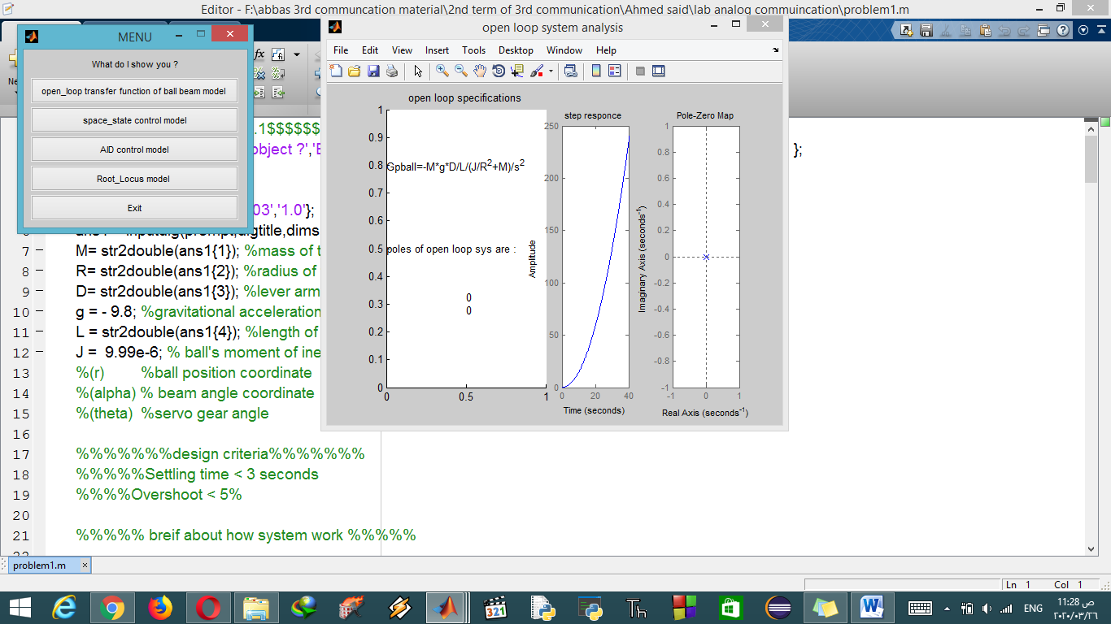

**Show with hand written analysis how you get poles ,damping ratio, and natural**

**frequency of system to meet the specification**

**damping ratio:**

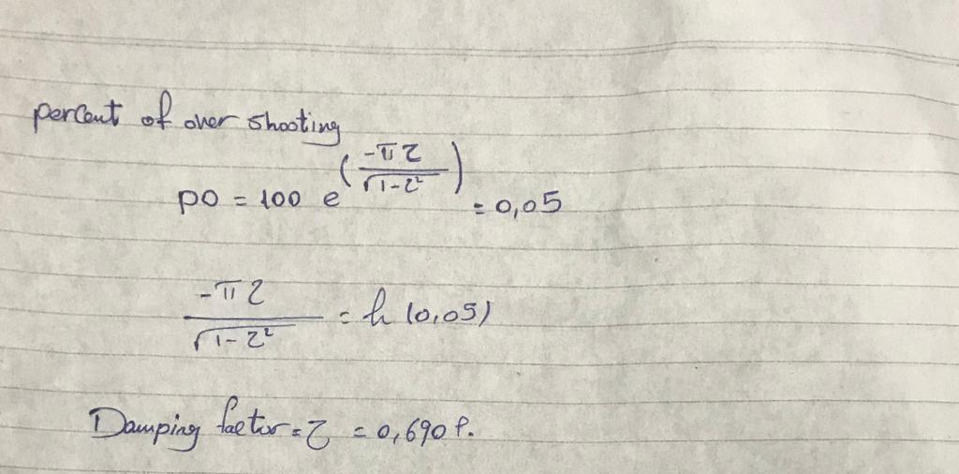**natural frequency:**

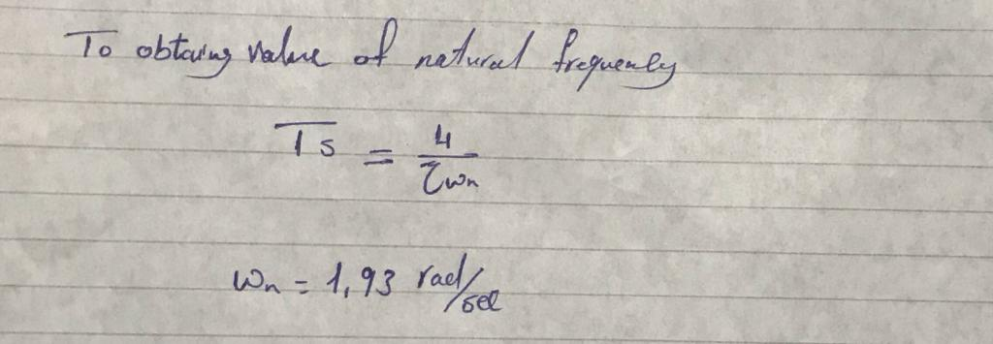

**to optain poles :**

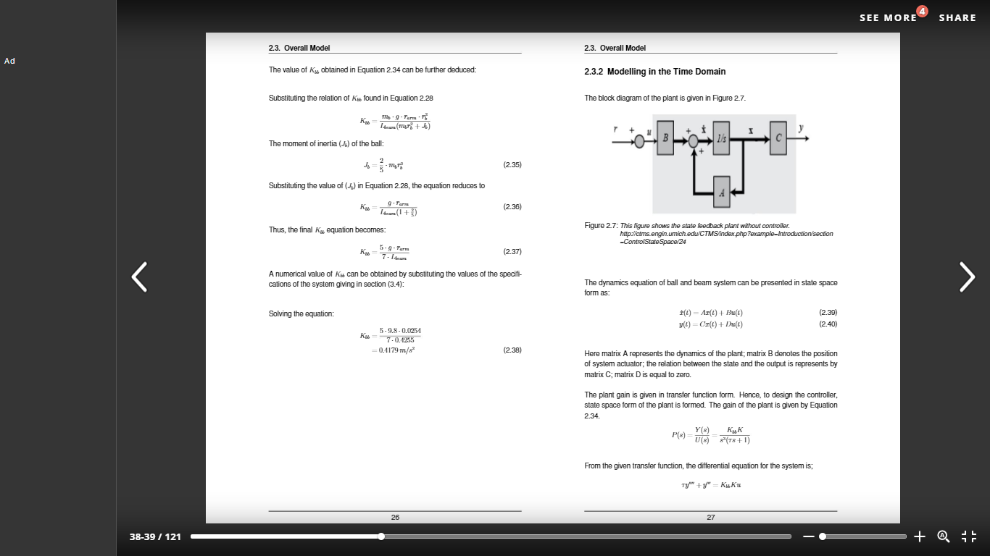

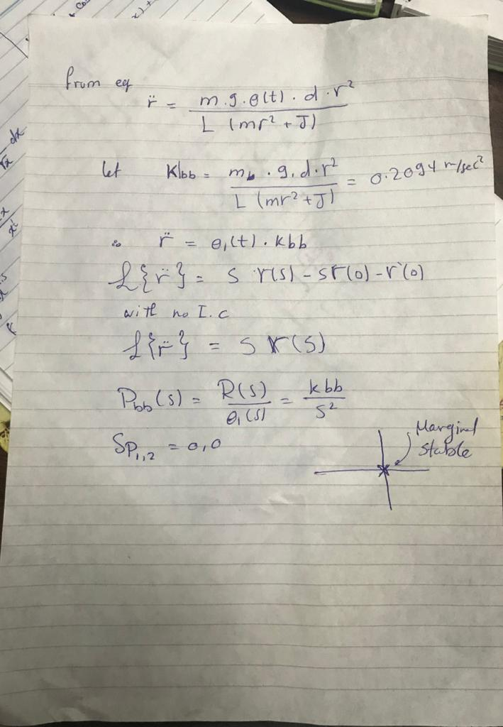

the ball & beam system **is marginal stable** but controllable system . An assumption is made that state variable are measurable the controller measures all the variables in the system at all time, for the ball & beam system , the controller measure the control current of the motor ,velocity & position of the ball here pole placement technique can be applied to control the system are placed at the desired location using space state feedback

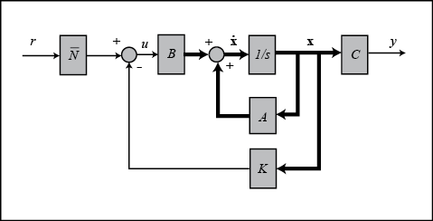

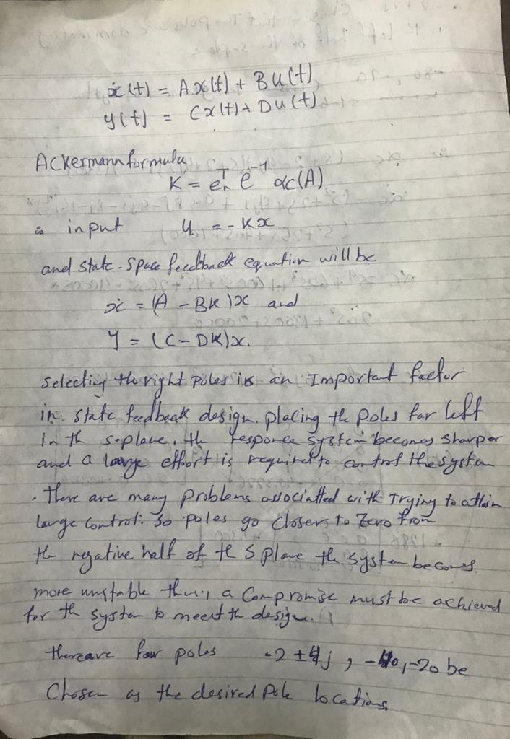

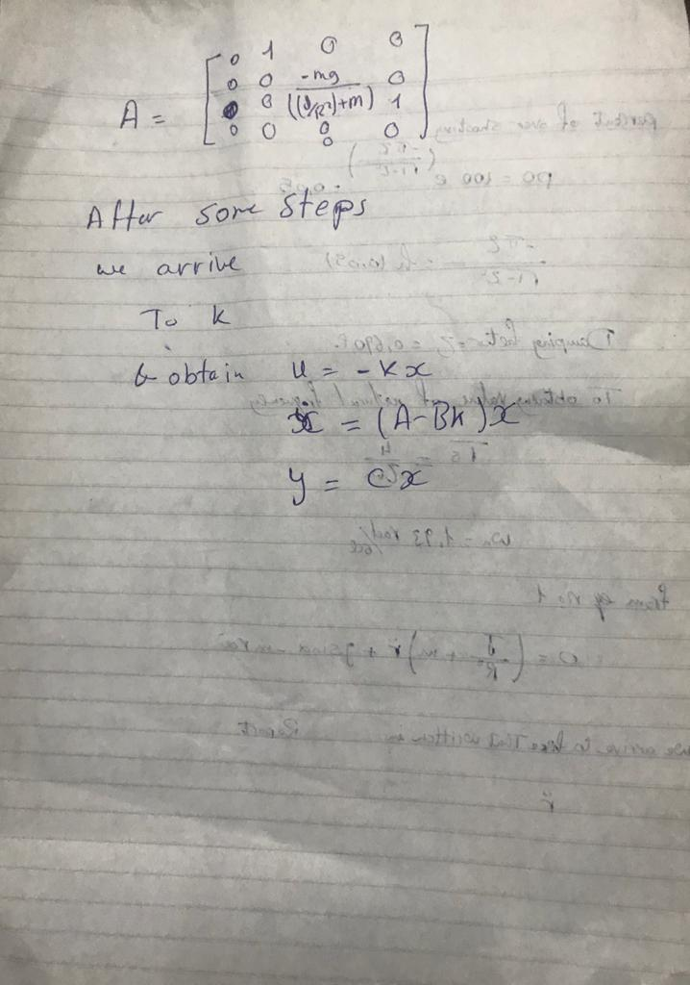

**How could you solve the steady state error problem**.

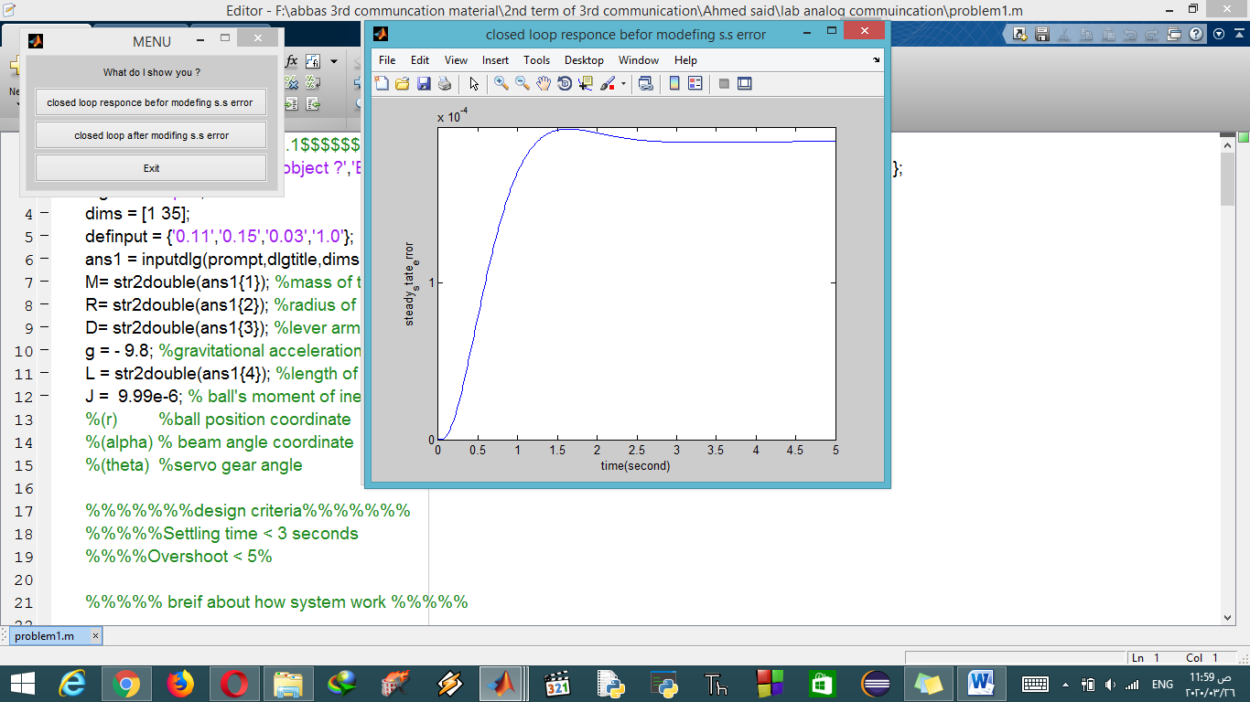

From this plot we see that there is a large steady state error, to compensate for this, we will need to add a reference input compensation,like this

Now we want to get rid of the steady-state error. In contrast to the other design methods, where we feedback the output and compare it to the reference input to compute an error, with a full-state feedback controller we are feeding back both states. We need to compute what the steady-state value of the states should be, multiply that by the chosen gain $K$, and use a new value as our reference for computing the input. This can be done by adding a constant gain $\overline{N}$ after the reference. The schematic below shows this relationship



**Try to improve the system specifications settling time or overshoot**

. However, the overshoot and settling time criteria are met. If we wanted to reduce the overshoot further, we could make the imaginary part of the pole smaller than the real part. Also, if we wanted a faster settling time we would move the poles further in the left-half plane. Feel free to experiment with the pole positions to see these trends.